* **Excel Lecture- 6**
* **INTRODUCTION TO POWER QUERY (GET AND TRANSFORM):**

= Available in Excel 2010,13,16

= Inbuilt in Excel 2016

🡪 Extract

🡪 Transform

🡪 Load

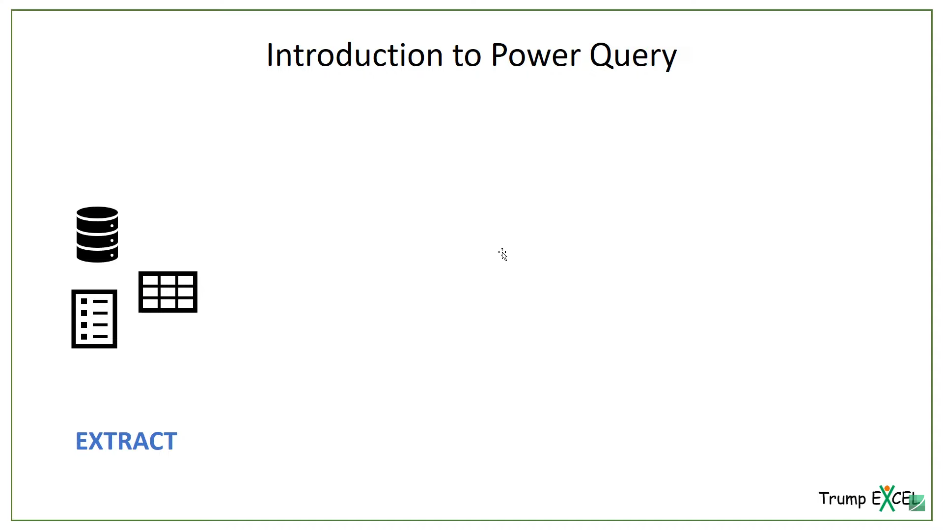

Extract the Data from multiple sources

* Data bases
* Manual data
* Csv
* Text file
* Web

Extract All the data in One Place

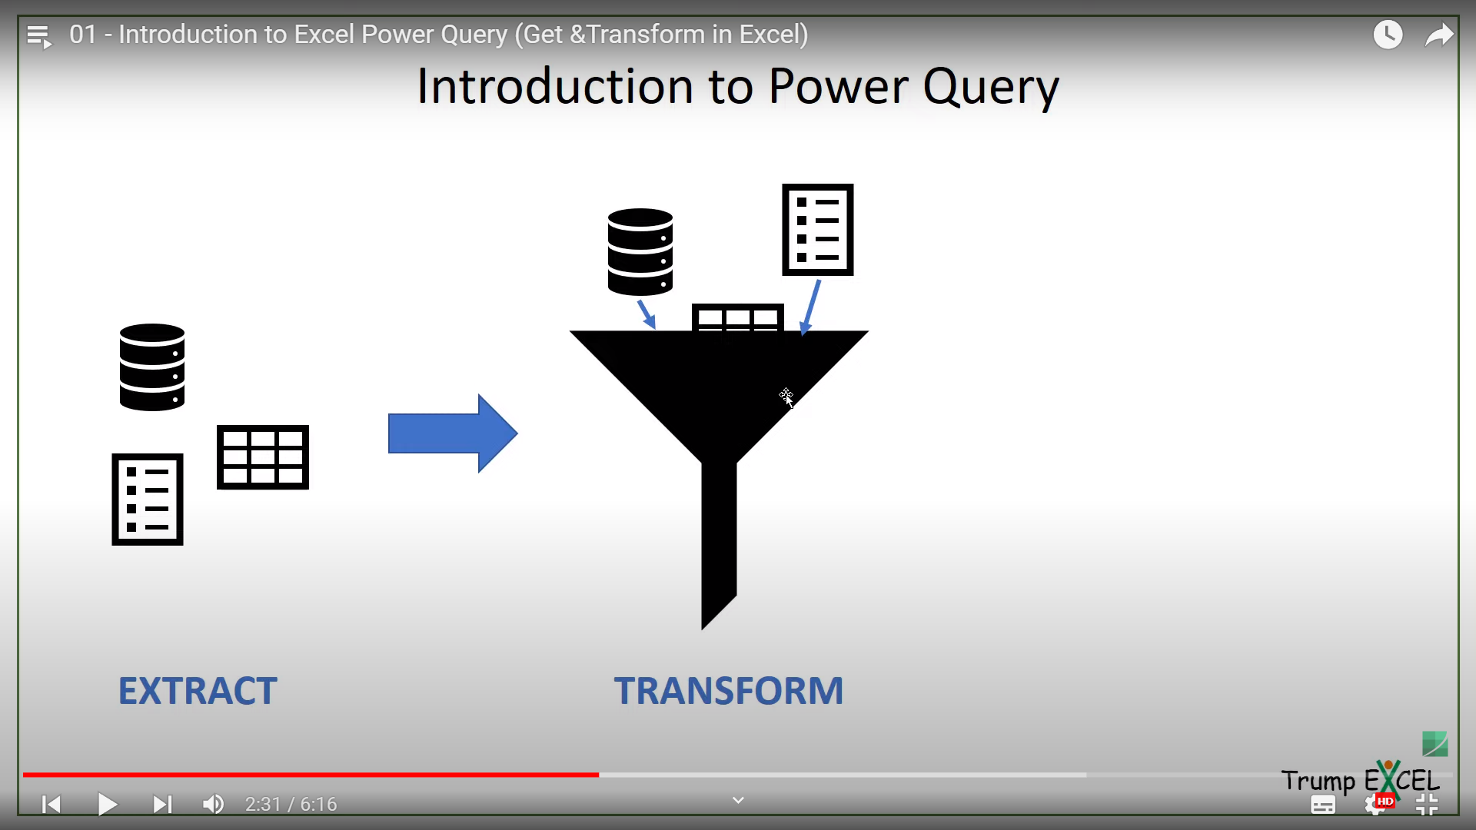

Transform the Data from multiple sources

* Remove Duplicates
* Remove extra columns
* Remove blanks or Error
* Transform it

Transform it in way to do meaning full analysis

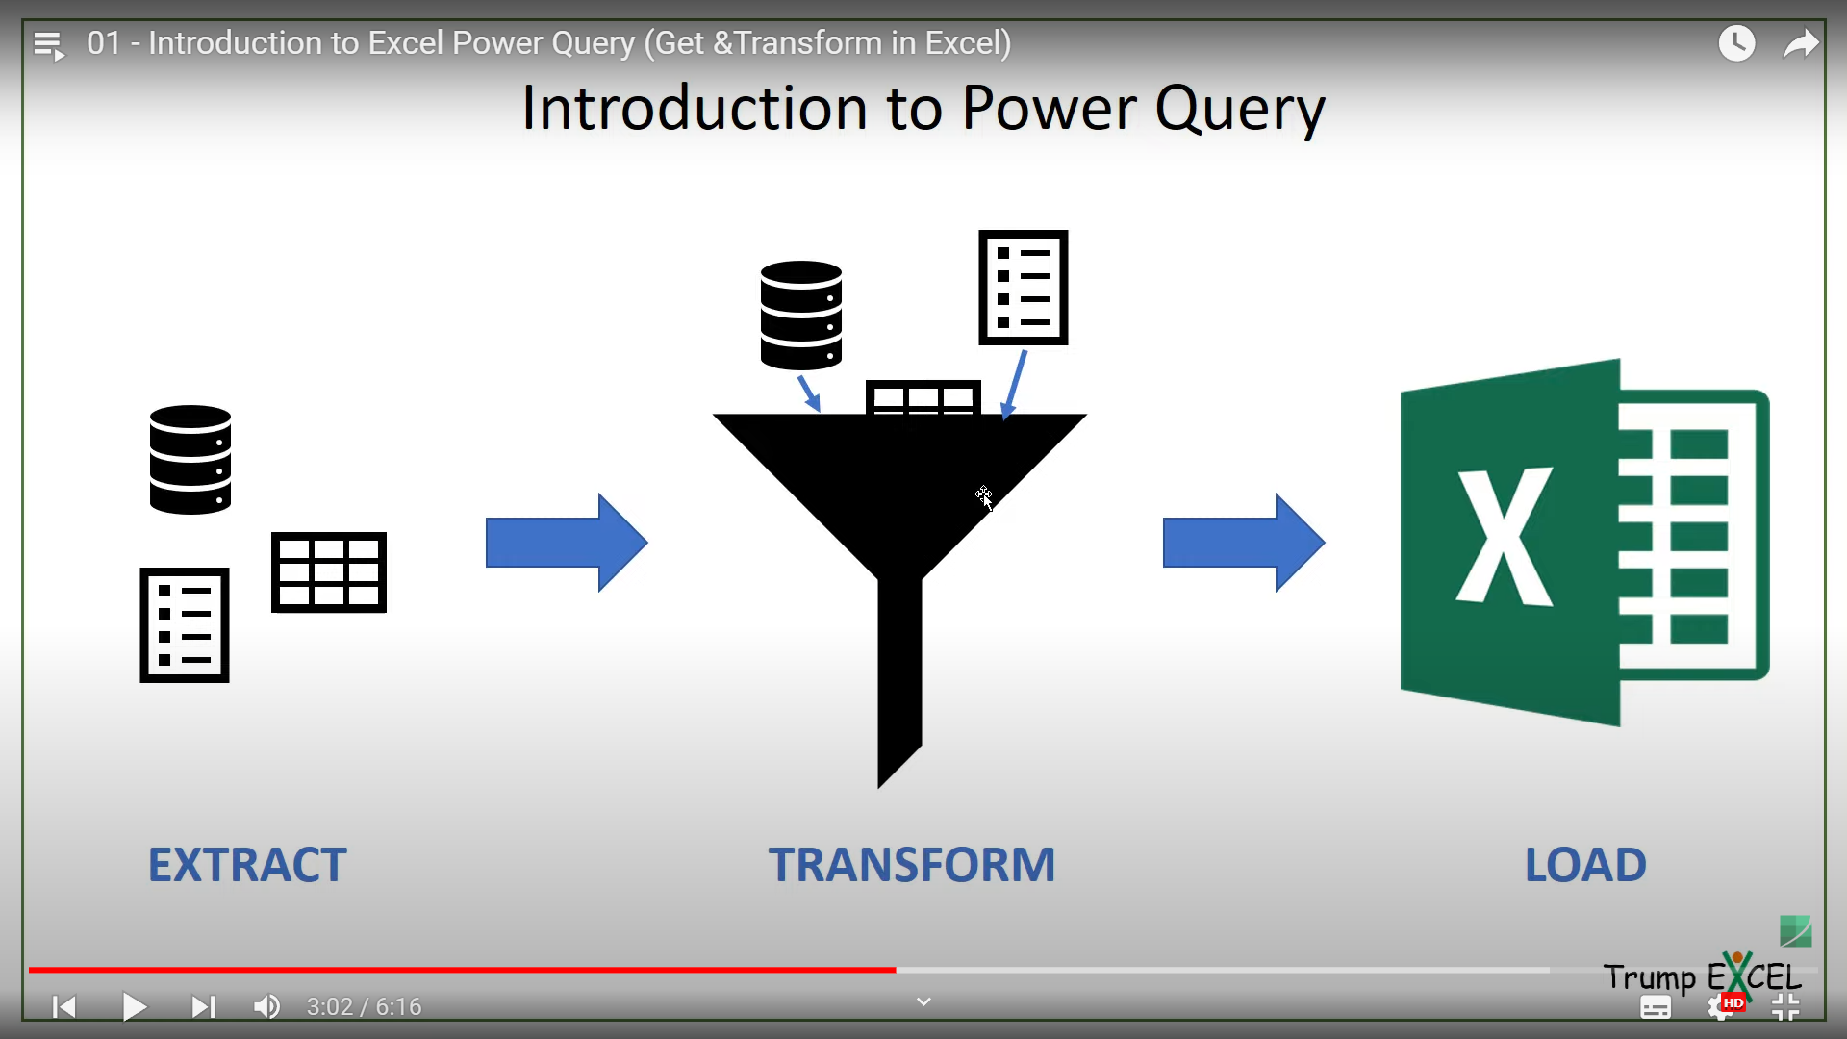

Load the Data in multiple sources

* Excel
* Python
* SQL

Anywhere where we want to create or show the reports.

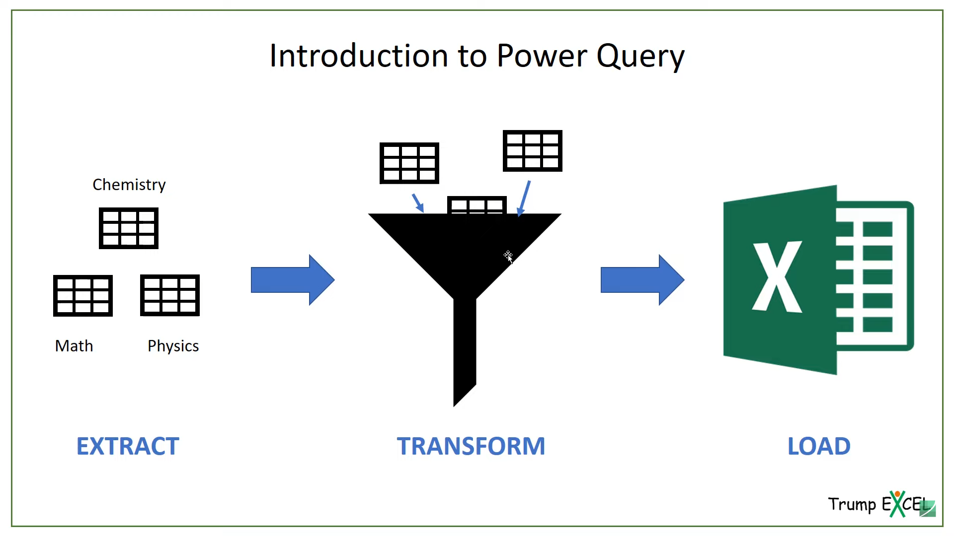

* **STEPS TO INSTALLING POWER QUERY (GET AND TRANSFORM):**

= Download Power Query Add in

= Goto Download

= select 32/64 bit

-Home 🡪 Options 🡪 Add in

* **Overview of Power Query:**

= Query Editor 🡪get data 🡪from other sources 🡪Blank Query